3D Weather in the Classroom

**Hurricane Katrina vs. Typhoon Tip**

1. **Overview**

Understanding why a tropical cyclone can be called a hurricane or a typhoon. Tropical cyclone is the scientific term for this type of storm but depending on where in the world the system is located depends on the name. Hurricanes form in the North Atlantic Ocean, North Pacific Ocean, and eastern North Pacific Ocean. Typhoons form in the Northwest Pacific Ocean. Map

Figure 1: Hurricane vs. Typhoon naming regions.

In order for a tropical cyclone to develop, they need to form in the tropical regions where the ocean water is at least 80° F. These warm waters evaporate, which creates warm moist air as fuel for the tropical cyclone.

For the United States, many hurricanes form from disturbances that develop over Africa and blow westward across the tropical Atlantic. The warm, moist air rises into the atmosphere where it begins to cool. The water vapor then condenses into liquid droplets and forms large cumulonimbus clouds. This process continues as more warm air rises and circulation begins to form gathering a cluster of clouds. If the storm has the correct amount of fuel, the tropical cyclone will continue to grow larger from a tropical disturbance, a tropical depression, a tropical storm, and finally into a hurricane or typhoon. Depending on the wind speed and strength, a hurricane can fall into different categories on the Saffir-Simpson Scale.

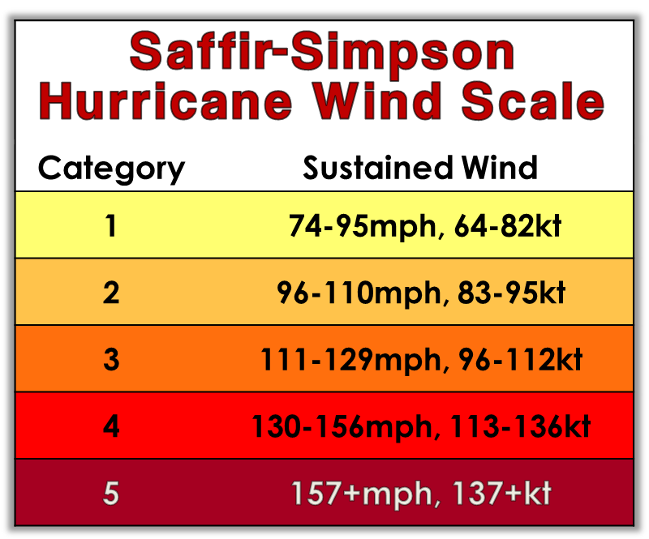

Figure 2: Winds speeds that determine the category of hurricanes.

**Hurricane Katrina**

Figure 3: Satellite image of Hurricane Katrina.

Hurricane Katrina began from the interactions of a tropical wave and the remains of a previous tropical depression. On August 23, 2005, Tropical Depression 12 formed and formed into Katrina a day later when it was over the Bahamas.

As Katrina moved North, it began to turn westward towards Florida. Hurricane Katrina first made landfall on August 25, 2005, in Florida between Miami and Fort Lauderdale. At this landfall, it was a category 1 hurricane and weakened into a tropical storm as it passed over land. Katrina only spent about 6 hours over land and then moved into the Gulf of Mexico.

Due to the warm waters of the Gulf of Mexico, Hurricane Katrina had the perfect ingredients to grow stronger. The warm gulf waters and low wind shear allowed Katrina to strengthened as it traveled through the gulf and quickly became a category 5 hurricane. As the storm traveled through the gulf, it doubled in size and intensified.

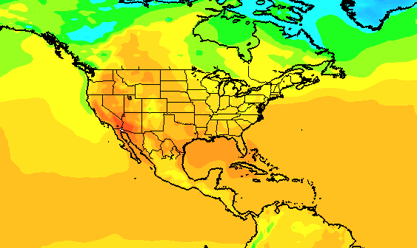

Figure 4: IDV image of sea surface temperatures on August 29th, 2005.

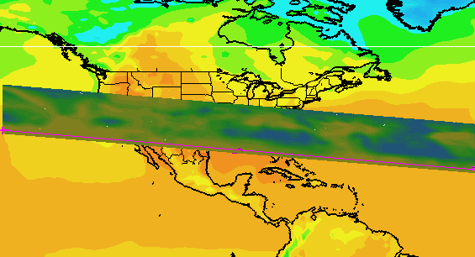

Figure 5: IDV image of sea surface temperatures with the corresponding vertical relative humidity profile on August 29th 2005.

The ridge in the upper troposphere helped guide Katrina towards the Louisiana and Mississippi Gulf Coast where Katrina made landfall near the mouth of the Pearl River. When the tropical cyclone made landfall for the second time on August 29. 2005 the storm weakened to a category 4 hurricane.

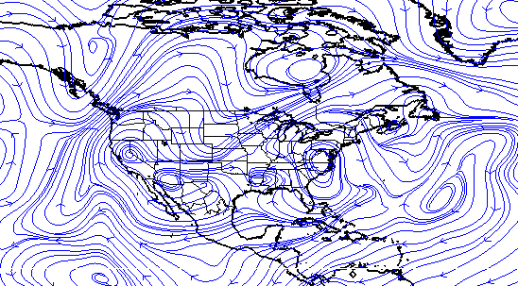  
Figure 6: IDV image of 300 mb streamlines on August 29th, 2005.

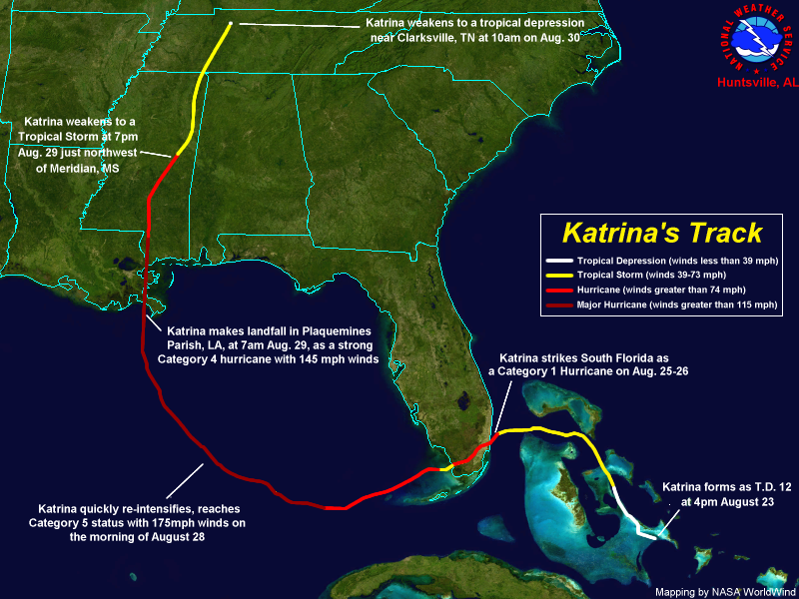

Figure 7: Hurricane Katrina’s path across Florida, The Gulf of Mexico, and into Louisiana and Mississippi.

Hurricane Katrina impacted about 90,000 square miles. The region affected by the storm supported roughly 1 million non-farm jobs, and still, hundreds of thousands of local residents were left unemployed by the hurricane.

**Typhoon Tip**

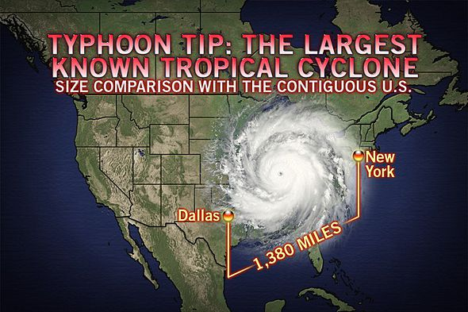

Figure 8: Satellite image of Typhoon Tip overlaid on the United States for size reference.

Typhoon Tip is the largest tropical cyclone on record. On October 3, a tropical system began to form in the Pacific Ocean. Because it was so close to another tropical storm, the tropical system was not able to strengthen very much. As this tropical system moved west, it eventually developed circulation and was upgraded to Tropical Depression 23. This tropical depression would then continue to intensify into Tropical Storm Tip but did not organize significantly due to the tropical storm nearby.

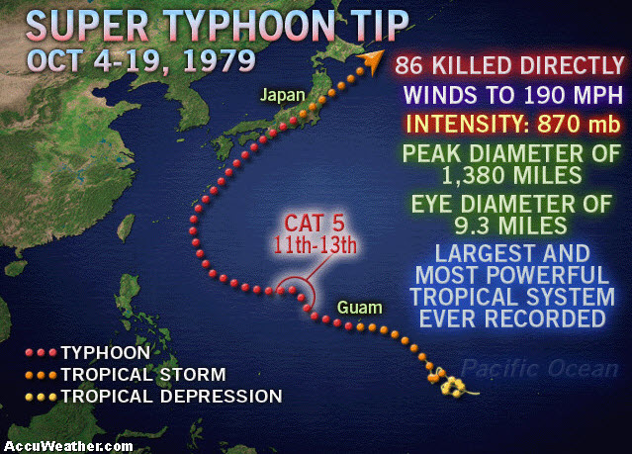

Figure 9: Typhoon Tip’s path in the Pacific Ocean.

As Tropical Storm Tip began to move further into the waters of the Pacific Ocean, the tropical cyclone reached a category 4 strength and became a “Super Typhoon”. The typhoon continued to grow in size until it reached a record diameter of 1,380 miles and eventually made landfall on the Japanese island of Honshu on October 19th.

Figure 10: Satellite image of Typhoon Tip.

**Katrina vs. Tip**

Katrina was able to form from the remains of a tropical depression. The fuel for the storm was already there and the environment was ideal for the cyclone to form. Once Katrina made landfall, it had time to strengthen before making landfall again. Katrina was able to keep growing until the very last minute before landfall.

Typhoon Tip was the largest tropical cyclone to ever form. However, it did not start that way. Tip was not able to strengthen for a while due to another storm taking the fuel from it. It took a long time for the typhoon to strengthen because the environment was not ideal. Once the typhoon moved further West, it was able to intensify until it became a Super Typhoon.

1. **IDV Project**

Since Typhoon Tip made landfall in 1979, we are not able to create an IDV file for it.

Project filename: “Katrina.xidv”

* Project data:
  + Filename: “[gfsanl_3_20050829_0000_000.grb](https://www.ncei.noaa.gov/data/global-forecast-system/access/historical/analysis/200508/20050829/gfsanl_3_20050829_0000_000.grb)”
  + 0.25°x0.25° Global Forecast System (GFS) analysis data for August 29, 2005 @ 00:00Z.
* Displays:
  + Maps
    - World country outlines.
  + Plan views
    - Surface temperature (°C) on August 29th, 2005
  + Cross sections
    - Relative Humidity (%) on August 29th, 2005
* Flow displays
  + 300 mb streamlines on August 29th, 2005.

Features to note:

* Figure 4 shows sea surface temperatures are high in the Caribbean Ocean and consistently stay warm along Katrina’s track.
  + High sea surface temperatures are the source of latent heat transfer which keeps Hurricane Katrina sustained.
* Figure 5 shows the vertical relative humidity profile from August 29th, 2005.
  + Along with high sea surface temperatures, high amounts of moisture through latent heat transfer are critical to hurricane development.
* Figure 6 shows the 300 mb streamlines from August 29th, 2005.
  + This shows the ridge in the upper troposphere that helped guide Katrina towards the Louisiana and Mississippi Gulf Coast.

1. **Knowledge Requirements**

* Module 1-1b: Energy Balance Over Ocean and Land
* Module 3-2: Measures of Moisture and Saturation
* Module 5-2: Pressure and Wind at Different Atmospheric Levels
* Module 7-1: Cold and Warm Fronts
* Module 7-3: 3D Structure of Mid-latitude Cyclone

1. **Knowledge Test:**

Question 1: What is another name for a tropical cyclone?

* A: Monsoon
* B: Hurricane
* C: Typhoon
* **D: Both B and C**

Question 2: What temperature does the water need to be for a tropical cyclone to form?

* A: At least 70 degrees F
* **B: At least 80 degrees F**
* C: At least 90 degrees F
* D: Less than 80 degrees F

Question 3: What category hurricane was Katrina when it made landfall the second time?

* A: Category 1
* B: Category 3
* C: Category 4
* **D: Category 5**

Question 4: Which is NOT a stage of the tropical cyclone life cycle?

* **A: Tropical tornado**
* B: Tropical storm
* C: Tropical disturbance
* D: Tropical depression

Question 5: How big was the largest typhoon to every form?

* A: 1,000 miles
* B: 1,500 miles
* **C: 1,380 miles**
* D: 1,230 miles

Question 6: How strong are winds in a category 5 hurricane?

* A: 74-95 mph
* B: 96-110 mph
* C: 130- 156 mph
* **D: 157 mph +**

Question 7: What is NOT an ingredient needed for a tropical cyclone to form?

* A: Warm sea surface temperatures
* **B: Dry air**
* C: Low wind shear
* D: Moisture in the atmosphere

Question 8: Katrina formed on the remains of a tropical ______

* **A: Depression**
* B: Storm
* C: Disturbance
* D: Cyclone

Question 9: What stopped Typhoon Tip from becoming stronger?

* A: Cooler Sea surface temperatures
* B: Did not have enough time
* **C: A nearby tropical cyclone**
* D: Not enough moisture

Question 10: Where did Katrina make landfall the second time?

* A: Florida
* **B: Louisiana**
* C: Mississippi
* D: Alabama